The ANC Market Social is a thriving outlet for local artisans, farmers, food vendors, and business. The open-air, outdoor market will be held each Sunday from May 19th through July 28th on E St between 5th and 6th Avenues and Town Square Park in beautiful downtown Anchorage.

- Vendors are invited to offer goods in several categories and MUST BE locally hand-crafted, hand-made, or home-grown.

- Live music performances each week.

ANC Market Social will be conducted on Sundays

Market Hours 11AM to 5PM

May 19 - July 28

Market Staff: Kris May, Events Director
Jordan McCulley, Events Coordinator

By submitting the 2024 ANC Market Social vendor application, applicants acknowledge they have received, understand, and agree to follow all policies and procedures set forth by Anchorage Downtown Partnership (herein referred to as “ADP”) and the ANC Market Social (herein referred to as “Market”). ADP reserves the right to remove any vendor at any time for failure to comply with the Market policies and procedures. ADP retains the right to prohibit a vendor from participation in the Market for violation of the policies without refund.

Market management recommends submitting an application as early as possible as vendor spots are limited.

Application acceptance is not guaranteed

CATEGORIES – The Market includes several categories as defined below:

1.Produce Fresh, home-grown local produce.
2.Florals/Plants: Fresh cut and dried flowers, succulents, seeds/seedlings/flats, potted plants, bushes, and herbs.
3.Baked Goods/Specialty Food Items: Baked goods include breads, pies, cookies, cakes and other homemade foods. Specialty Foods include jams, jellies, honeys, and granola, etc.
4.Arts/Crafts: Homemade, hand-crafted items to include candles, soaps, jewelry, textiles, garden arts, and other art/craft items.
5.Prepared Foods: Ready-to-eat items such as sandwiches, grilled items, and snack foods.
6.Merchant: Downtown Anchorage businesses may occupy space to sell store’s merchandise/food. Merchant spaces MAY NOT be sublet and are subject to all other Market rules.
7.Other: Agricultural/farm items that do not fall into the above categories (meats, eggs, cheese, poultry, seafood, nuts, etc.) subject to appropriate certification as required by local/state/federal regulations.

PRODUCT AND MERCHANDISE GUIDELINES
Crafts, art, jewelry, clothing, etc., must be original creations crafted by the vendor/artist.

Mass-produced items or franchised items such as Avon, Mary Kay, Paparazzi, Pampered Chef, etc. are NOT eligible vendor products.

The primary focus of the Market is locally grown, so fresh produce and agricultural items must be produced or grown at local farms/gardens or businesses. Brokered produce and produce grown outside of the Anchorage area will be allowed with pre approval from Market staff.

No marijuana products.

No political items or candidates.

ACCEPTANCE
In addition to maintaining an appropriate vendor mix, vendor selection is based on quality of product, date of application, and Market experience with the vendor.

Vendors will be notified by email.

Applicants not selected as vendors may be placed on a waiting list for weekly vendor openings or full-time spots as vacancy in category occurs.

ATTENDANCE
In an effort to maintain a full and active market, all vendors are required to notify the ADP office of any absences by 9:00 AM the Friday before the Market to allow timely notification of wait-listed vendors.

Vendors should limit absences to three (3) per season. Excessive absences may result in loss of assigned space for the remainder of the season and will render a vendor ineligible to receive any discounts.

PRODUCTS & LABELING
Vendors are required to comply with the State of Alaska Division of Agriculture guidelines for food products sold at events sponsored by non-profit organizations.

All vendors are strongly encouraged to display product pricing in a clear and visible manner.

Vendors are responsible for obtaining all necessary licenses and certifications required by the Municipality of Anchorage.

All Market vendors are required to comply with the Municipality of Anchorage regulations governing the preparation, handling, and presentation of food. Environmental Services staff will inspect booths during the set-up period to ensure standards are met.

For more information on product labeling and food handling guidelines, required licenses, and certifications please contact the Anchorage Health Department, Environmental Services/Food Safety & Sanitation Department at (907) 343-4200 or www.muni.org/EHonline.

LIABILITY
All vendors are required to sign the Hold Harmless clause included in this application. Vendors assume all responsibility for the operation of their booth and any damages or injuries that may occur in that area during normal hours of Market operation or from consumption of products or goods.

All merchandise will be handled and displayed at the vendor’s risk and ADP assumes no responsibility for theft, accident or natural disaster.

Vendor insurance coverage is not provided by the ADP or the Market staff, therefore, each vendor must carry his/her own liability insurance. Vendors should contact their insurance provider to ensure proper coverage for Market participation and to obtain a certificate listing the ANC Market Social.

SPACE RESERVATIONS
- Each Market space is approximately 10’ by 10’.
- Seasonal vendors enjoy a discount and are assigned the same booth location for the entire season.
- Double spaces are allowed (no more than two spaces are allowed per vendor).
- Vendors MAY NOT sublet or share space.

VENDOR FEES

ART/CRAFT VENDOR
Seasonal $1,100 (Save $275)
Monthly $375 (Save $100 - Available in June and July)
Weekly $125

BAKED GOODS, SPECIALTY FOOD, PREPARED FOOD
Seasonal $950 (Save $150)
Monthly $330 (Save $70 - Available in June and July)
Weekly $100

PRODUCE, PLANT, FARM OR AGRICULTURAL VENDOR
Seasonal $450 (Save $100)
Monthly $150 (Save $50 - Available in June and July)
Weekly $50

- *Due to credit card fees incurred by us through our bank, vendors paying by credit card will be charged a 3% credit card payment fee. To avoid this charge, vendors may pay by cash or check.

PAYMENT SCHEDULE
Seasonal vendors
- A deposit of 50% of the vendor fee (per space) is required within 7 days of Market acceptance of SEASONAL applications.
- The remaining SEASONAL vendor fees must be paid prior to the June 23, 2024 Market.
- Once accepted, SEASONAL vendors withdrawing after June 23, 2024 (for ANY reason) will not receive a deposit refund.

Monthly and Weekly vendors
- MONTHLY AND WEEKLY payments must be prepaid no later than 12:00 PM on Friday before Market Sunday.

VENDOR OPERATIONAL GUIDELINES

- Official Market hours are from 11:00 AM to 5:00 PM each Sunday, from May 19th through July 28th.
- Vendors will be notified weekly, by email, of their booth location.
- Check in required at ADP information booth before unload can begin.
- Set-up time is from 8:00 AM to 10:30 AM.
- Please be setup and ready to sell by 10:45 AM.
- Vendors not checked in by 10:00 AM may be relocated.
- Vendors arriving late to the Market MUST check in with the Market staff prior to unloading and may be denied vending and will not receive a refund.
- Vendors will be permitted to drive into the market from 8am-10am.
- Vehicles must enter the Market area from 6th Avenue (Diamond Parking Lot) and exit from 5th ave.
- All Vehicles MUST be out of Market area by 10am.
- Vendors MUST unload vehicles and move vehicles before setup can begin if vehicles are in Market area (on E street, not the parking lot)
- Vehicles must be relocated to public parking areas by 10:45 AM.
- Vendors may access Market for breakdown after ADP staff moves barricades and ensures safety of pedestrians.
- Vendors are responsible for all set-up items such as tables, chairs, canopies, and hand-washing stations (no water outlet available on site).
- Canopies MUST BE secured with 10 lb. weight on all four (4) sides to sustain wind gusts as required by the Municipality of Anchorage. More weight is recommended.
- Only whisper-soft/quiet generators such as Honda EU series inverter models or equivalent are allowed and must be pre-approved by ADP staff.
- All prepared food vendors MUST have a 5 lb. fire extinguisher with appropriate tagging.
- Children and pets must be under direct supervision at all times.
- Vendors are responsible for collecting and removing all vendor trash.
- Vendors are prohibited from using the City and Park trash receptacles. Trash cans are available in and around the Market area for vendor use.
- Food vendors/ food trucks must pack out their own trash generated by food production.
- Booth space must be cleaned at the end of each Market.
- Food vendors MUST place a mat or tarp under any area where food is cooked to protect the ground surfaces.

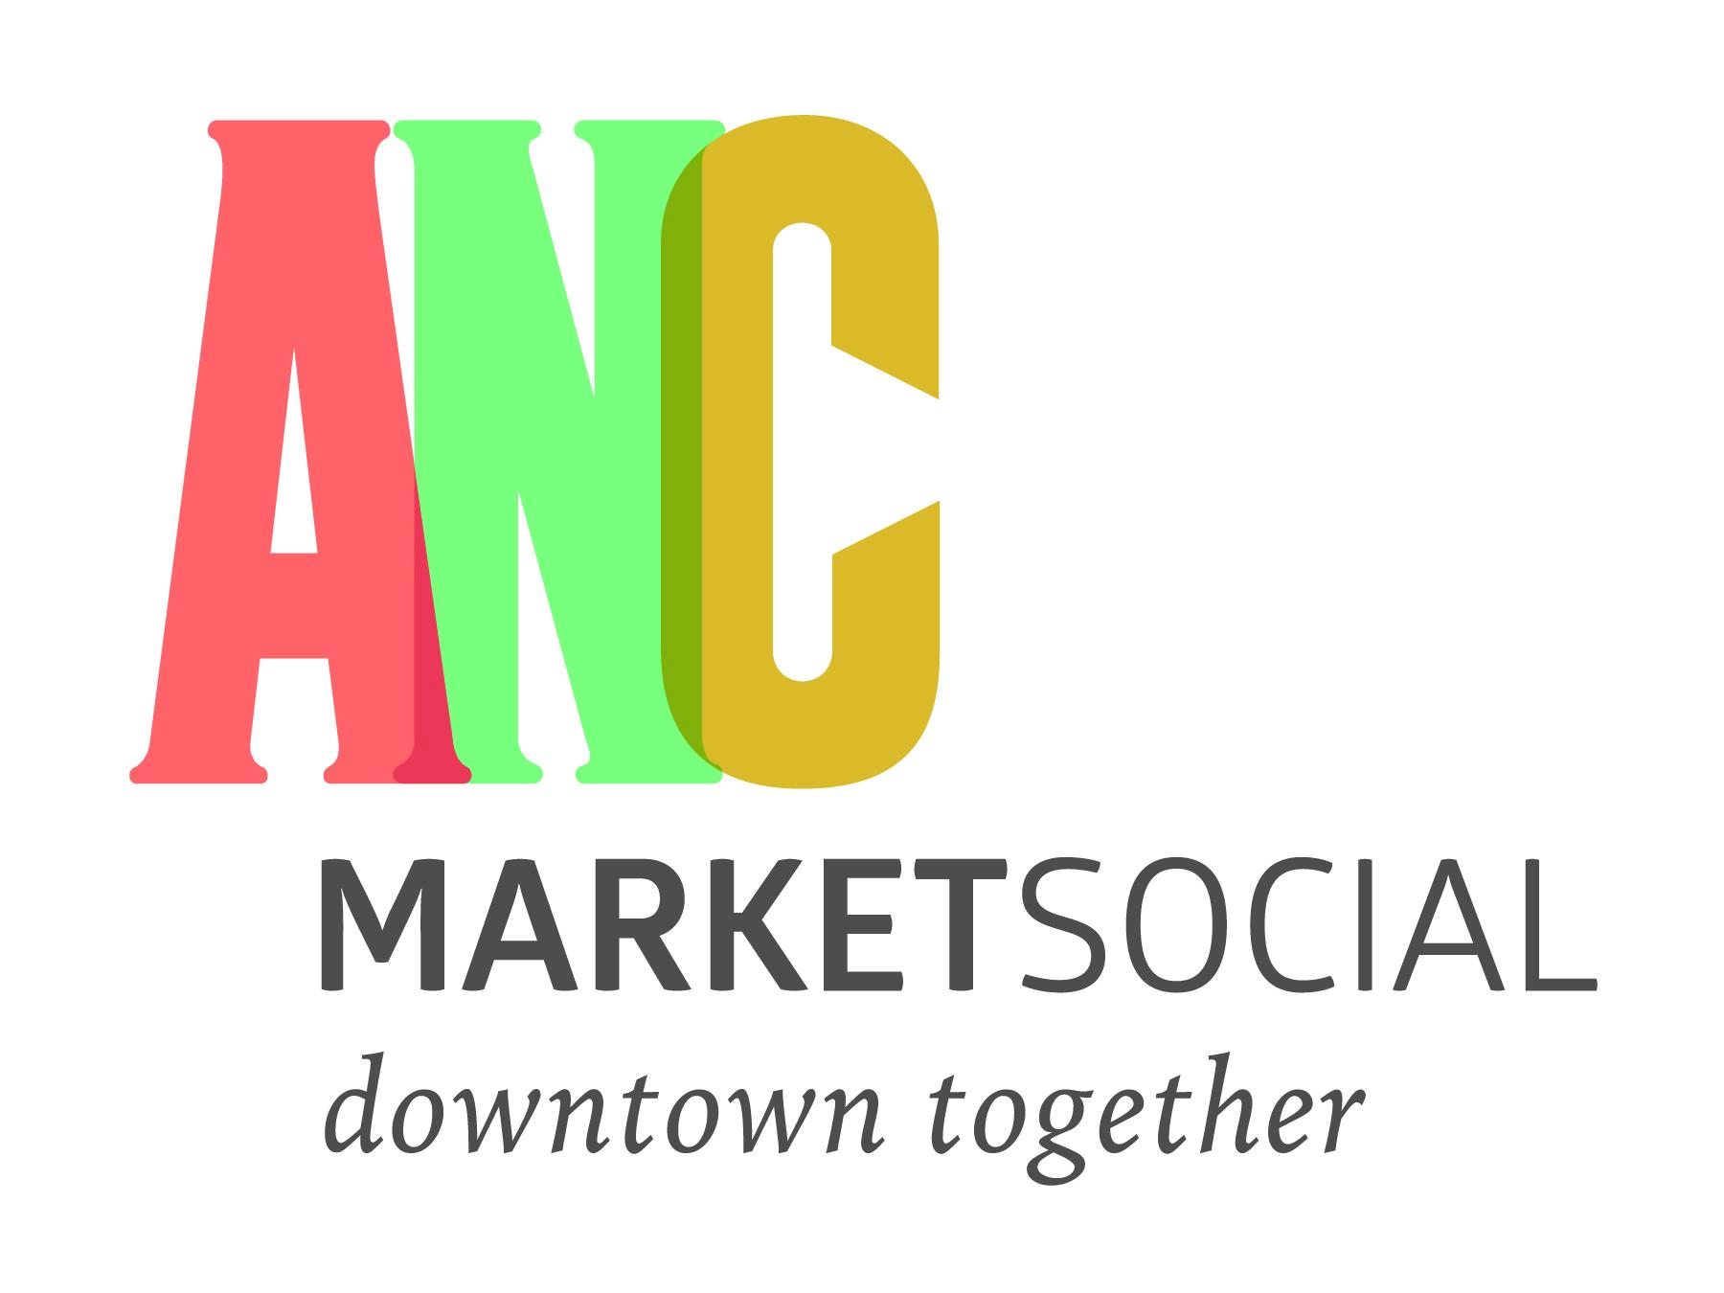
Name: _________________________

Business Name: _____________________________________

Address: ___________________________________________

City: ___________________ State: ______ Zip Code:_______________

Mobile Number: _______________

Email: __________________________________

Please mark your primary product category:
- Produce
- Florals/Plant
- Baked Goods/ Speciality Food Items
- Arts/Crafts
- Prepared Foods
- Downtown Merchant
- Non Profit Organization
- Other (please specify)_________________________________

Market Dates (Check all the applicable dates)
- May 19
- May 26
- June 2
- June 9
- June 16 **Seasonal Vendors and Monthly vendors will receive discounts**
- June 23
- June 30
- July 7
- July 14
- July 21
- July 28

Hold Harmless Clause
PLEASE READ, SIGN, AND DATE

All authorized vendors participating in the ANC Market Social are independent operators and not partners or joint ventures and shall be individually and severally liable for any loss, personal injury, deaths, and/or any other damages that may occur as a result of the vendor’s negligence or that of its employees, agents, and associates. In consideration of being allowed to participate, all vendors agree to indemnify ANC Market Social, Anchorage Downtown Partnership, Ltd., City of Anchorage affiliates, and volunteers harmless from any loss, costs, damages, or other expenses including attorney’s fees, suffered or incurred by ANC Market Social by reason of vendor’s negligence or intentional misconduct or that of its employees, agents, and associates; provided that the vendor shall not be liable for nor required to indemnify ANC Market Social, Anchorage Downtown Partnership, Ltd., City of Anchorage, affiliates, and volunteers for any negligence of any of them or that of their servants, agents, employees or associates. I further give approval for ADP to use photographs and/or video images taken at this event, which might include images of personnel, affiliates, and products for publicity purposes.

Signature: ___________________________________
Date: _________________________

Please include a Certificate of Insurance (COI) with your completed application.

Email application to ANCMarket@anchoragedowntown.org.

ADP accepts cash, check, or credit card (+3% fee) as forms of payment.
Vendors will be invoiced using SQUARE.

Please make checks out to: ADP Community Services.

Mailing address: Anchorage Downtown Partnership Attn: ANC Market Social, 750 W. 2nd Avenue, Suite 100, Anchorage, AK 99501.

